
In this post a few PowerBI Management Dashboards are presented.
Dashboard nr 1 is a Region Analysis dashboard driven by 7 years of data of a large US company selling 6 products in 35 different industries.
Dashboard nr 2 is a Multi-Year performance Analysis Dashboard driven by the same 7 years of data of the large US company selling 6 products in 35 different industries.
Dashboard nr 3 is a Retail analysis dashboard driven by 3 years of data from a US Retailer.
Dashboard nr 1 – Region Analysis
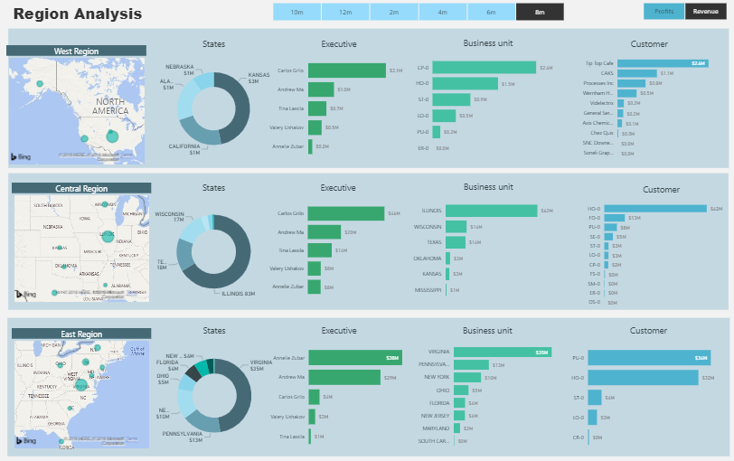
Download the PBI file here: https://goo.gl/EABUR2
Dashboard nr 1 – Datamodel
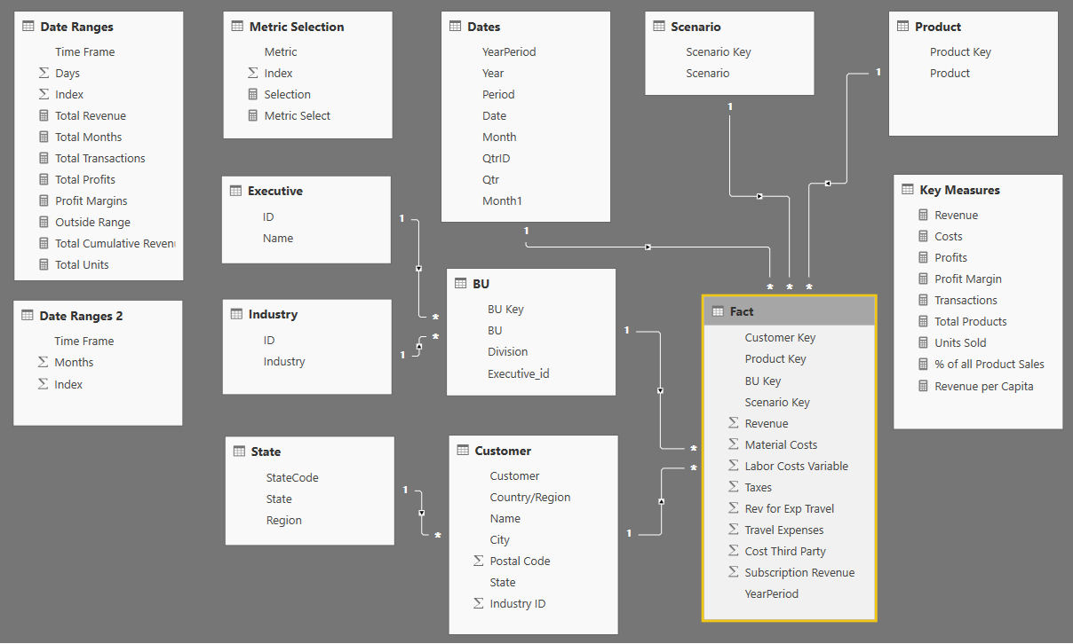

Dashboard nr 2 – Multi-Year Performance Analysis
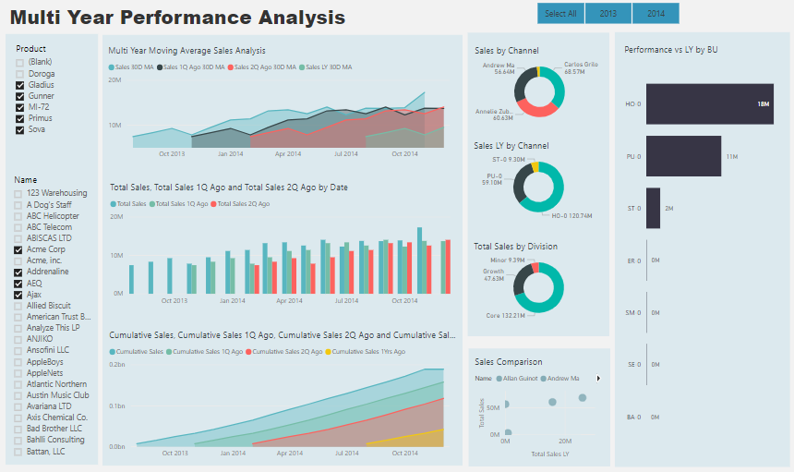
Download the PBI file here: https://goo.gl/Pvu7Hy
Dashboard nr 2 – Datamodel
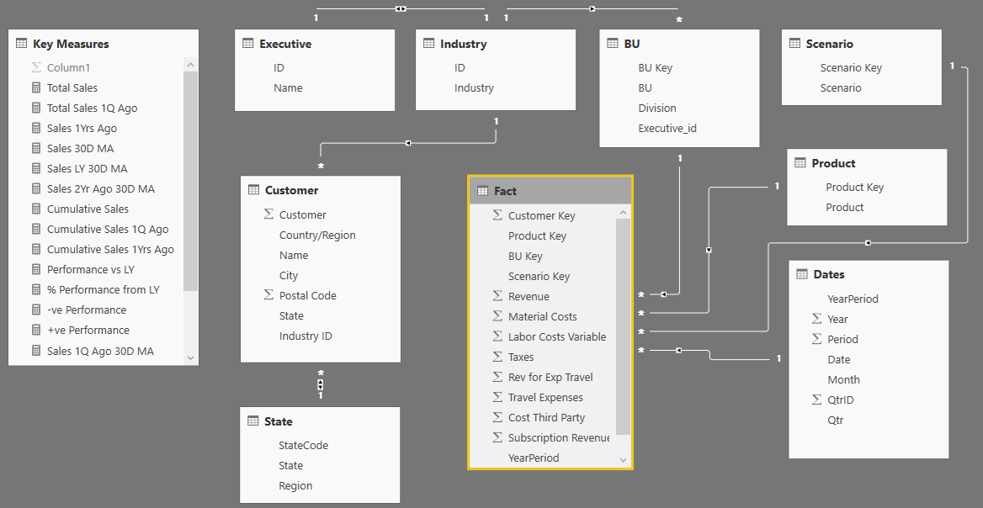

Dashboard nr 3 – Retail Analysis Dashboard
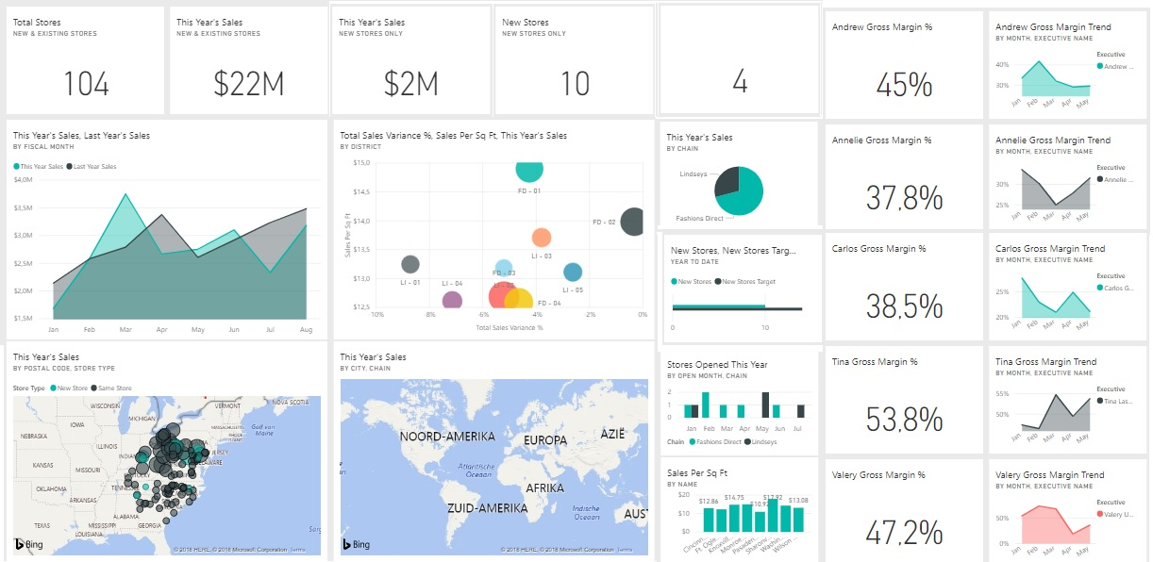
Download the PBI file here:
Dashboard nr 3 – Datamodel
